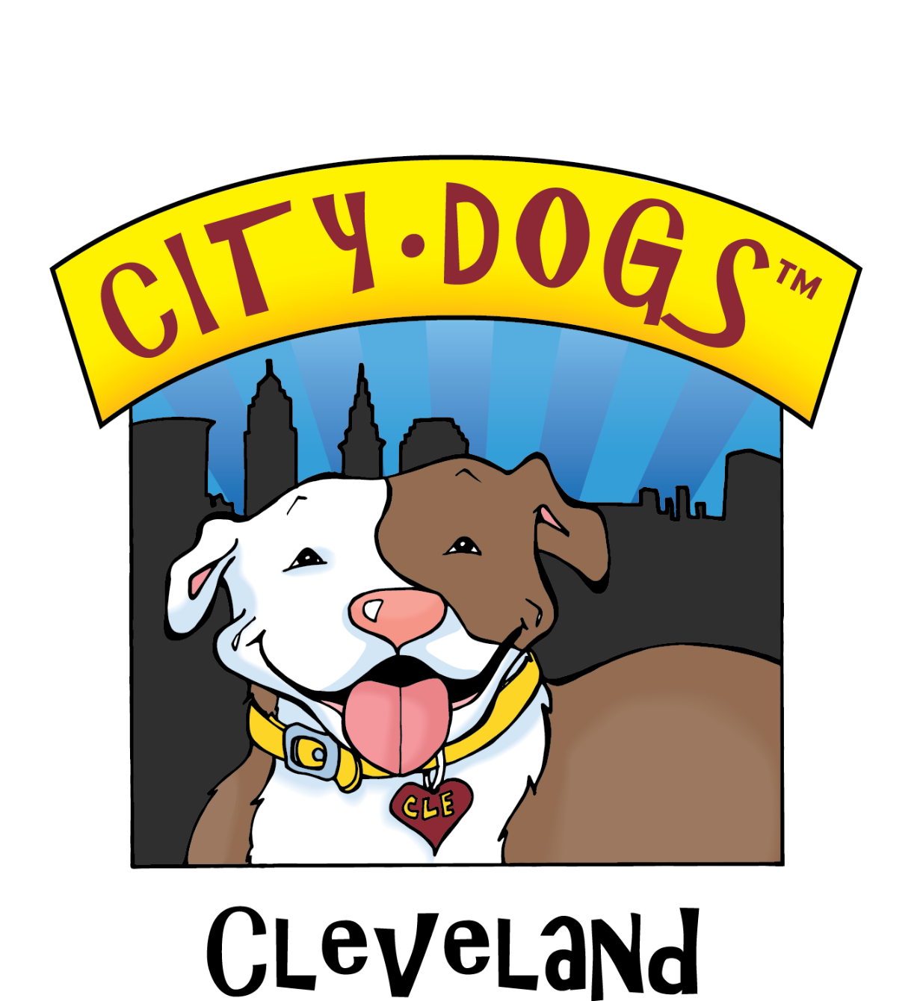
CITY DOGS MARKETING STRATEGY PROJECT
Harnessing our marketing efforts for the long run

KICK-OFF QUESTIONNAIRE

KICK-OFF QUESTIONAIRE

Thanks for participating in the effort to strengthen City Dogs’ marketing communications program.

We can’t know which way to go without having a sense of where we stand, so please take adequate time to thoughtfully answer as many of the questions below as you feel you have something you want to share.

Please type your answers in RED after each question, save this WORD doc with your name added to the file name, then email to rdemuesy@sbcglobal.net by January 1.

Include your email to receive the details on when and where the follow-up 4-hour Workshop will be held.

Your email: who@where.what

How long have you been volunteering/working at City Dogs?
Answer …

Based on what you know/feel:
—what’s the difference between APL, County, City Dogs?
Answer …
—What is each best at?
Answer …
—How does/can each complement the other?
Answer …
—Any notion of how the public thinks/feels about each?
Answer …

The myths about Pitties
—What do you think are the top three myths?
Answer …
—How prevalent (or not) do you think these misunderstandings still are today?
Answer …
—Do we need to address/answer them somewhere in our marketing communications? Why or why not?
Answer …
—Was there any particular myth you bought into, and then found it/yourself blown away when you met your very first pittie?
Answer …

On finding fosters:
—What kinds of things have been done in the past to find/entice fosters?
Answer …
—What’s worked?
Answer …
—How do you know it’s worked?
Answer …

On attracting adopters:
—What kinds of things have been done in the past to find/entice adopters?
Answer …
—What’s worked?
Answer …
—How do you know it’s worked?
Answer …

On gaining volunteers:
—What kinds of things have been done in the past to find/entice volunteers?
Answer …
—What’s worked?
Answer …
—How do you know it’s worked?
Answer …

What single City Dogs marketing element do you believe excels more than all the others? Why do you say that?
Answer …

What’s the best promotional idea for any shelter you’ve ever seen? What did you like best about it?
Answer …

What is your reason for showing up to City Dogs?
Answer …

How did you first hear of City Dogs?
Answer …

What element of City Dogs makes you proudest to volunteer here?
Answer …

Who are we?
Of these choices in the wheel below, which 3 does City Digs most embody … and why?
Pick/rank/explain from #1 to #3 …

#1 Answer ...
#2 Answer …
#3 Answer …
